An overview of population undernutrition in a selection of countries in east and southern Africa

Australian International Food Security Centre

Anne Marie Sanderson¹ and Chris Auricht²
August 2012
- Australian International Food Security Centre, GPO Box 1571, Canberra, ACT 2601 (E: aifsc@aciar.gov.au)
- Auricht Projects, PO Box 400, Brighton South Australia, 5048 (E: chris@auricht.com)

Contents
Introduction 4
Undernutrition 6
Indicators of population nutrition 6
Country profiles 7
Child undernutrition 7
Maternal undernutrition 15
Micronutrient deficiencies 18
Iron deficiency 19
Vitamin A deficiency 23
Iodine deficiency 26
Conclusion 26
References 27
Annex 1 – List of references for Demographic Health Survey reports 28
Annex 2 Country summaries and discussion 29

List of Tables
Table 1 Indicators of nutritional status 8
Table 2 Severity of rates of undernutrition in a population of children 0 – 59 months 9
Table 3 Prevalence of children 0 – 59 months with underweight, stunting and wasting 9
Table 4 Severity classification for population prevalence of stunting, wasting and underweight 10
Table 5 Prevalence of maternal short stature and low1 BMI in selected countries 15
Table 6 WHO cut-off values for the public health significance of rates of low BMI 15
Table 7 Rates of anaemia in women aged 15 – 49 in selected countries 18
Table 8 Rates of anaemia in children aged 6 – 59 months in selected countries 19
Table 9 Public health significance of population prevalence rates of anaemia¹ 19
Table 10 Prevalence of low serum retinol in preschool-aged children 22
Table 11 Prevalence of low serum retinol in pregnant women 22
Table 12 Iodine nutrition in selected countries 25

List of Maps
Map 1 Distribution of underweight amongst focus countries at the district scale 12
Map 2 Distribution of wasting amongst focus countries at the district scale 13
Map 3 Distribution of stunting amongst focus countries at the district scale 14
Map 4 Distribution of rates of BMI <18.5 kg/m² amongst focus countries at the district scale 17
Map 5 District level distribution of rates of anaemia in women 15 – 49 (where available) 21
Map 6 District level distribution of rates of anaemia in children 6 – 59 months (where available) 22
Map 7 Vitamin A deficiency amongst primary school-aged children 24
Map 8 Vitamin A deficiency amongst pregnant women 25

List of Figures
Figure 1 Framework of the relations between poverty, food insecurity, and undernutrition 5
Figure 2 Prevalence of wasting, stunting and underweight in children (0 – 59 months). 11
Figure 3 Prevalence of short stature (<145cm) and BMI <18.5 kg/m² in women 15 – 49 years old. 16

An overview of population undernutrition in a selection of countries in east and southern Africa

Introduction
Close links exist amongst food security (including agriculture), social protection (including emergency relief) and health (including maternal and child health care, immunisation and family planning). Links exist too between food security, nutrition and broader determinants of poverty status such as education, water supply and sanitation and cross-cutting issues like gender equity and governance (SUN Movement 2011). In the first of five articles in the Lancet series on nutrition, Black et al. 2008 present a framework for the relations between poverty, food insecurity and other underlying and immediate causes of maternal and child undernutrition along with short-term and long-term consequences. This is presented in Figure 1 from Black et al. 2008 below.
The outcomes of food insecurity can be considered from a variety of perspectives—economic, social, or environmental. Figure 1 illustrates pathways through which these various dimensions of food security and nutrition manifest in maternal and child undernutrition. The long-term consequences of maternal and child undernutrition are also highlighted, and include adult size, intellectual ability and economic productivity—all of which can ‘feedback’ at the level of basic and underlying causes of undernutrition, poverty and food insecurity such as lack of capital and income poverty.
Beneath both immediate and underlying causes of undernutrition sit factors such as poverty, inequity, social norms, levels of maternal education and the status of women in a particular society (UNICEF 2009). Whether it be through a lack of opportunity or capacity, unfavourable social, economic and environmental settings often restrict people’s educational attainment, incomes, assets and opportunities for food production or economic resilience. Household food security, ability to care for and properly nourish young children in the critical ‘1000-day window’ between conception and two years, health of women of child-bearing age, and access to proper household hygiene and primary health care—all play a role in the manifestation of maternal and child nutritional outcomes.
This paper aims to discuss the basic physiological indicators of undernutrition at the population level, and why these factors are important in the cycle of undernutrition, food insecurity and poverty.
We present a series of summary statistics on nutrition for Burundi, Ethiopia, Kenya, Malawi, Mozambique, Rwanda, Uganda, the United Republic of Tanzania and Zambia. The data have been collected from the latest demographic health surveys and other global databases on population nutrition status. These profiles aim to present the latest statistical snapshots of each country for major indicators of maternal and child nutrition.

Figure 1 Framework of the relations between poverty, food insecurity, and undernutrition
These data aim to serve as a starting point for the conversation going forward at the AIFSC Nutrition Workshop. We invite you and your organisations to bring your expertise, contemporary knowledge and country perspectives on nutrition and food security in this region to the discussion. We hope that you can assist us with the development of an information base and understanding of the most pertinent nutrition and food security challenges in the region, that is up to date and as accurate as possible. This workshop also aims to discuss the key drivers, trends and issues affecting nutrition and food security in the region, in order to identify where we can best partner with other efforts underway in the region.

Undernutrition
Undernutrition is considered as one of the world’s most serious but least addressed health problems (SUN Movement 2011). Undernutrition encompasses stunting, wasting, underweight and deficiencies of essential vitamins and minerals, collectively referred to as micronutrient deficiencies (Black et al. 2008). Undernutrition is an important determinant of maternal and child health (Black et al. 2008) and is the outcome of factors including insufficient food intake, inadequate care and infectious diseases (UNICEF 2009).
Maternal and child undernutrition contribute to more than one third of child deaths (Black et al. 2008; UNICEF 2009; World Food Programme 2012). Children who are undernourished, not optimally breastfed or suffering from micronutrient deficiencies have substantially lower chances of survival than children who are well nourished. They are much more likely to suffer from serious infection and to die from common childhood illnesses such as diarrhoea, measles, pneumonia and malaria, as well as HIV/AIDS. Chronic undernutrition in early childhood also results in diminished cognitive and physical development, putting children at a disadvantage for the rest of their lives (UNICEF 2009).
A child’s future nutrition status is affected before conception and is greatly dependent on the mother’s nutrition status prior to, and during pregnancy. A chronically undernourished woman is likely to give birth to a baby who is also likely to be undernourished as a child, causing the cycle of undernutrition to be repeated over generations. Undernourished children who survive may become locked in a cycle of recurring illness and faltering growth, with irreversible damage to their development and cognitive abilities (UNICEF 2009).
Micronutrients are essential vitamins and minerals required by the body in miniscule amounts throughout life. A micronutrient deficiency occurs when the body does not have sufficient amounts of a vitamin or mineral due to insufficient dietary intake and/or insufficient absorption and/or suboptimal utilisation of the vitamin or mineral (UNICEF 2009). Health outcomes relating to micronutrient deficiencies include iron deficiency anaemia, iodine deficiency disorders and blindness (Black et al. 2008).
Between conception and two years of age, lack of access to an adequate diet for a couple of months or more deprives children of essential nutrients, leading to micronutrient deficiencies, constrained development and stunting. Once a child reaches two years of age, most of this damage cannot be undone (World Food Programme 2012).

Indicators of population nutrition
Common indicators of population nutrition captured by Demographic and Health Surveys (DHS) include key measurements of children, and women of child-bearing age (15 – 49 years). Indicators include wasting, stunting and underweight amongst children under five years old, maternal thinness or body mass index (BMI), and prevalence of low birthweight babies (<2500 g).

Country profiles
This paper aims to present a snapshot of nutrition indicators for countries in the AIFSC priority area of east and southern Africa; namely: Burundi, Ethiopia, Kenya, Malawi, Mozambique, Rwanda, Uganda, the United Republic of Tanzania and Zambia.
This selection of indicators captures measurements of undernutrition rather than malnutrition more broadly—with rates of obesity or other measures of ‘over nutrition’ and nutrition-related non-communicable diseases such as diabetes and heart disease exempt. We invite you to raise these issues in the discussion on nutrition if you believe they play a significant role in the nutrition issues affecting people in this region.
While some DHS reports are based on data collected in very recent times, other country datasets are based on data collected some time ago (see Annex 1). Food security, nutrition and other drivers of public health are of course dynamic and changing. Obvious examples are the food price shocks of 2008 and the Horn of Africa crisis over the past few years that has had, and continues to have, a profound effect on the food security and nutrition of many populations in the region. It is acknowledged therefore, that the next DHS reports may indeed paint a very different picture of nutrition in the region.

Child undernutrition
In a well-nourished population, there is a standard distribution of height and weight for children under age five (Botswana CSO 2009). Undernourishment in a population can be assessed by comparing children to a reference distribution. In 2006 the World Health Organisation (WHO) conducted the WHO Multicentre Growth Reference Study (WHO 2006). In the study 8,440 children in six countries (Brazil, Ghana, India, Norway, Oman and the United States) were measured to describe how children should grow under optimal conditions.

The outcome of the study was the WHO Child Growth Standards that are now used as the reference population for assessment of child growth worldwide. These new Growth Standards replace the previously used NCHS/CDC/WHO reference standards, upon which some earlier child nutrition studies were based. There are three nutritional status indicators used to express rates of undernutrition, all of which are expressed in standard deviation units (z-scores) from the median of this reference population. These are stunting prevalence, underweight prevalence and wasting prevalence. Table 1 below explains these indicators in more detail.

Stunting is a low height for age relative to the reference population. Stunting is a reflection of chronic malnutrition as a result of failure to receive adequate nutrition over a long period and recurrent or chronic illness. Children whose height for age is more than two standard deviations below the median of the reference population are considered short for their age and are classified as moderately or severely stunted. Those whose height for age is more than three standard deviations below the median of the reference population are classified as severely stunted. Stunting affects approximately 195 million children under five years old in the developing world, with 90 per cent of these children living in Asia and Africa (UNICEF 2009). While rates of stunting in Asia dropped from 44 per cent in 1990 to 29 per cent in 2008, rates in Africa have only dropped from 38 to 34 per cent between 1990 and 2008. The overall number of children who are stunted has increased from an estimate of 43 million in 1990 to 52 million in 2008 (UNICEF 2009). Stunting holds back development of nations, and its prevention can protect and improve the livelihoods of entire societies (WFP 2012).

Underweight is a measurement of weight for age and is an indicator of both acute and chronic malnutrition. Children whose weight for age is more than two standard deviations below the median of the reference population are considered moderately or severely underweight. Those whose weight for age is more than three standard deviations below the median are classified as severely underweight. It is estimated that 129 million children under five years old in the developing world are underweight; nearly one in four. The prevalence of underweight is higher in Asia (27 percent) than Africa (21 percent) (UNICEF 2009).

Wasting is a low weight for height relative to the reference population. Wasting is usually the result of a recent nutritional deficiency. The indicator may exhibit significant seasonal shifts associated with changes in the availability of food or disease prevalence. Children who are more than two standard deviations below the median of the reference population are classified as moderately or severely wasted. Those children who fall more than three standard deviations below the median are severely wasted. Children who suffer from wasting face a markedly increased risk of death. It is estimated that 13 percent of children under five years old in the developing world are wasted, with 5 percent severely wasted. These percentages account for approximately 26 million children (UNICEF 2009).

Table 1 Indicators of nutritional status
Indicator Name | Definition | Numerator | Denominator
Stunting prevalence | Percentage of children under five years old whose height falls below minus two (moderate and severe) and below minus three (severe) standard deviations from the median height for age of the reference population | Number of children under five years whose height a) falls below minus two standard deviations (moderate and severe)  b) falls below minus three standard deviations (severe) from the median height for age of the reference population | Total number of children under five years old
Underweight prevalence | Percentage of children under five years old whose weight falls below minus two (moderate and severe) and below minus three (severe) standard deviations from the median weight for age of the reference population | Number of children under five years old whose weight a) falls below minus two standard deviations (moderate and severe)  b) falls below minus three standard deviations (severe) from the median weight for age of the reference population | Total number of children under five years old
Wasting prevalence | Percentage of children under five years old whose weight falls below minus two (moderate and severe) and below minus three (severe) standard deviations from the median weight for height of the reference population | Number of children under five years old whose weight a) falls below minus two standard deviations (moderate and severe)  b) falls below minus three standard deviations (severe)  from the median weight for height of the reference population | Total number of children under five years old

The severity of these indicators of child undernutrition to a population’s health has also been classified by WHO. The severity of the prevalence (as a percentage) of underweight, wasting and stunting in the population of children aged 0 – 59 months (i.e. under five years) is considered by WHO as low, medium, high or very high, according to Table 2 below.

Table 2 Severity of rates of undernutrition in a population of children 0 – 59 months
Indicator | Prevalence
 | Low | Medium | High | Very high
Underweight (% with weight-for-age <-2 Z-scores) | <10 | 10 – 19 | 20 -29 | ≥30
Wasting (% with weight-for-height <-2 Z-scores) | <5 | 5 - 9 | 10 -14 | ≥15
Stunting (% with height-for-age <-2 Z-scores) | <20 | 20 - 29 | 30-39 | ≥40
Source : WHO 2012a
Table 3 and Figure 2 below present a collection of statistics on stunting, wasting and underweight for a series of countries in the region, while Map 1, Map 2 and Map 3 present these same data spatially at the sub-national scale. The source of these data is the respective DHS reports available for each country. Results show stunting rates in several countries to be ‘very high’ (>40 percent) while the percentages of wasting and underweight in most countries fell in the ‘medium’ category for severity (see Table 4).
Table 3 Prevalence of children 0-59 months with underweight, stunting and wasting¹
 |  | Prevalence of undernutrition in children 0-59 months (%)
 |  | Underweight | Stunting | Wasting
 |  | (Weight for age) | (Height for age) | (Weight-for-height)
Country | Year² | <-2 Z-scores | <-2 Z-scores | <-2 Z-scores
Burundi | 2010 | 28.8 | 57.7 | 5.8
Ethiopia | 2011 | 28.7 | 44.4 | 9.7
Kenya | 2008-09 | 16.0 | 35.0 | 7.0
Malawi | 2010 | 12.8 | 47.1 | 4.0
Mozambique | 2011 | 14.9 | 42.6 | 5.9
Rwanda | 2010 | 11.4 | 44.2 | 2.8
Uganda | 2006 | 15.9 | 38.1 | 6.1
United Republic of Tanzania | 2010 | 15.8 | 42.0 | 4.8
Zambia | 2007 | 14.6 | 45.4 | 5.2
Mean | - | 17.6 | 44.1 | 5.7
- <-2 Z-scores below WHO 2006 reference standards
- See Annex 1 for sources of data

Table 4 Severity classification for population prevalence of stunting, wasting and underweight
 | Underweight  (% <-2 Z-scores) | Stunting  (% <-2 Z-scores) | Wasting  (% <-2 Z-scores)
Key
Low | <10 | <20 | <5
Medium | 10 to 19 | 20-29 | 5 to 9
High | 20-29 | 30-39 | 10 to 14
Very high | ≥30 | ≥40 | ≥15
Source : WHO 2012a

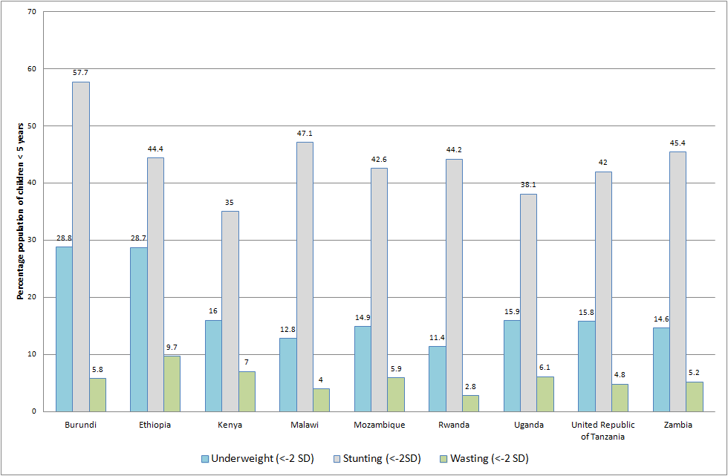
Figure 2 Prevalence of wasting, stunting and underweight in children (0 – 59 months).
Source: National DHS (see Annex 1)

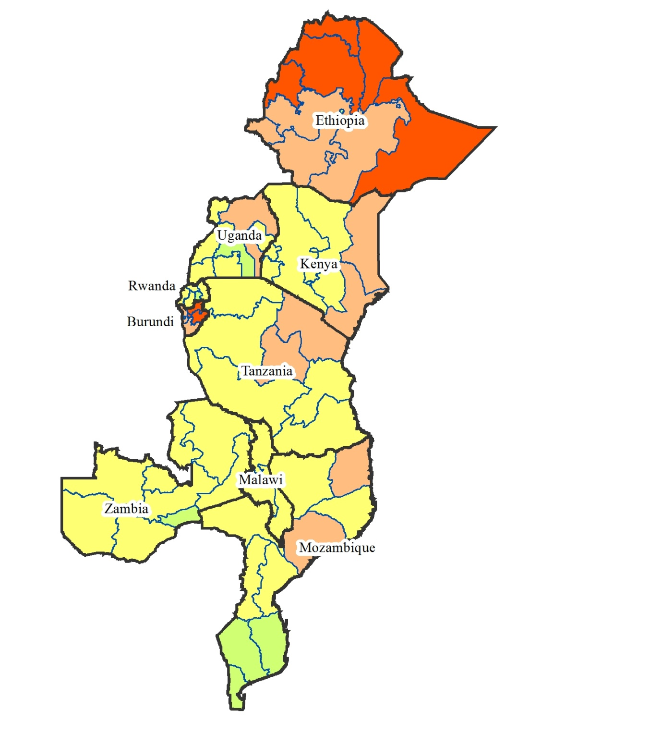

Legend | % Population <-2 Z-scores
Low | <10
Medium | 10 to 19
High | 20-29
Very high | ≥30

Map 1 Distribution of underweight amongst focus countries at the district scale
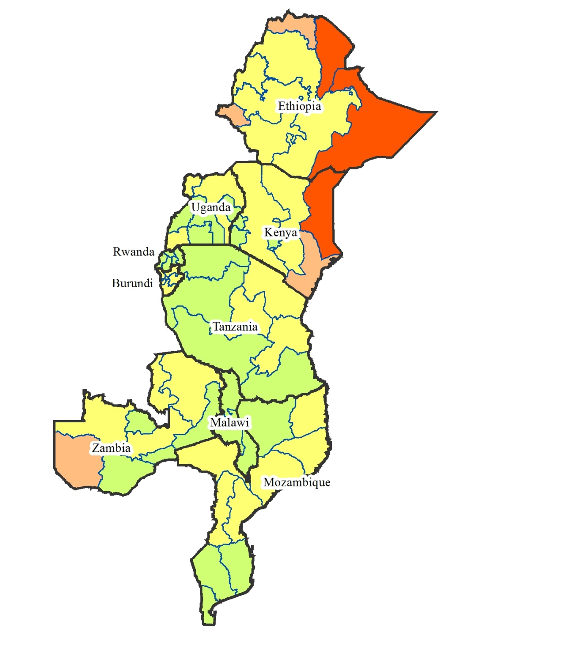

Legend | % Population <-2 Z-scores
Low | <5
Medium | 5 to 9
High | 10 to 14
Very high | ≥15

Map 2 Distribution of wasting amongst focus countries at the district scale

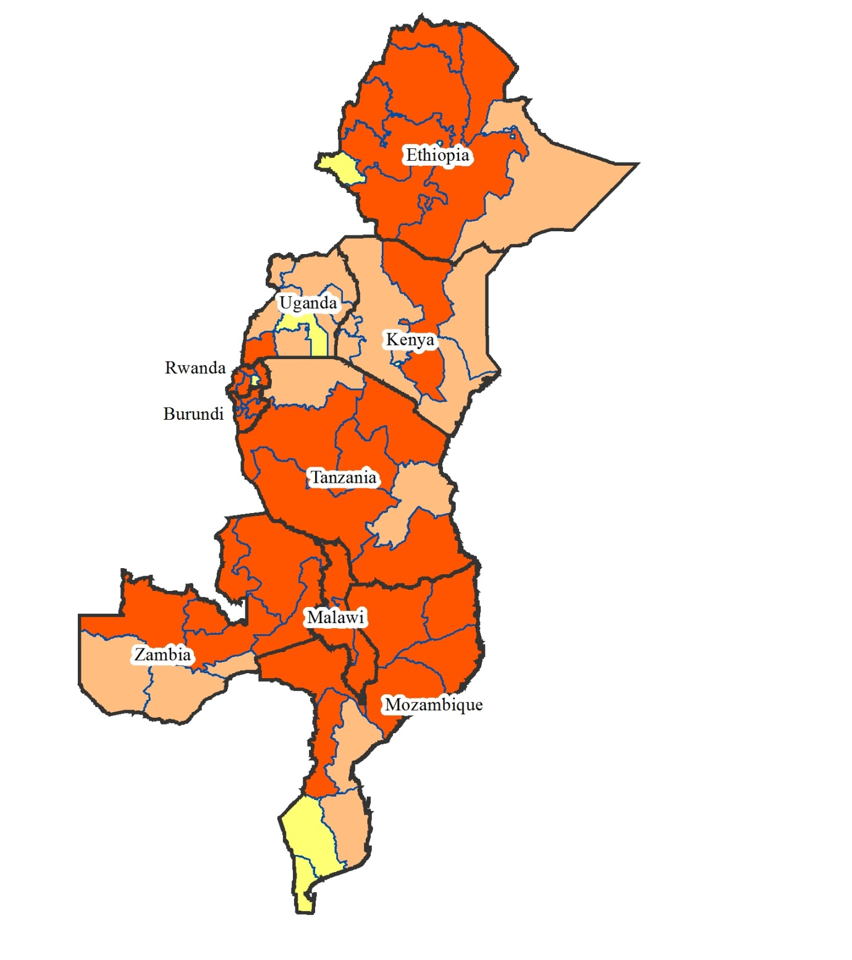

Legend | % population<-2 Z-scores
Low | <20
Medium | 20-29
High | 30-39
Very high | ≥40

Map 3 Distribution of stunting amongst focus countries at the district scale

Maternal undernutrition
It is well understood that a woman’s nutritional status has important implications for her health as well as for the health of her children (National Bureau of Statistics 2011). For women, chronic undernutrition either before birth or during early childhood can lead to their babies also being born with a low birthweight. This in turn can lead to these children also being undernourished, triggering a vicious cycle of undernutrition generation after generation (Basch 1999; UNICEF 2009). The nutritional status of women is assessed using two main indicators: height and BMI. This data is collected at a population scale amongst women aged 15 – 49 years.
Maternal short stature is a risk factor for poor birth outcomes and obstetric complications. A woman is considered to be at risk from short stature if her height is below 145 cm.
BMI is used to measure thinness or obesity. BMI is defined as weight in kilograms divided by height squared in metres (kg/m²). A BMI of below 18.5 indicates thinness or acute undernutrition. A BMI below 16 indicates severe undernutrition and is associated with increased mortality (National Bureau of Statistics 2011). Low pre-pregnancy BMI, like short stature, is associated with poor birth outcomes and obstetric complications. A BMI greater than or equal to 30 is classified as obese.
These anthropometric measures along with screening for maternal levels of key micronutrients including iron and iodine are the key indicators of maternal undernutrition. Infant and young child feeding practices including breastfeeding behaviours are also important nutritional statistics.
Table 5 and Figure 3 below present the prevalence of two common measures of nutrition for women aged 15 – 49. Heights less than 145 cm are classified as ‘short stature’ and considered a risk factor for obstetric complications. BMI is a measure of thinness or obesity. A BMI lower than 16 kg/m² indicates severe undernutrition and is associated with increased mortality. Low pre-pregnancy BMI is also associated with poor birth outcomes and obstetric complications, while a BMI greater than 30 kg/m² is classified as ‘obesity’.
While most of the data comes from the DHS reports for each respective country, for some countries these were not available, and the data was taken instead from the WHO Global Database on BMI (WHO 2012). As such, some data may be significantly out of date, such as that for Mozambique. A full list of the reference documents for Table 5 is presented in Annex 1.
These prevalence rates are compared to the WHO cut-off values for the public health significance (Table 6) of adults with a BMI <18.5 (not just for women 15 – 49). When compared to these standards, rates amongst these countries at the time of these surveys were generally low – medium. However, as with child undernutrition, these rates may have changed significantly following the serious food security shocks affecting some nations in recent years.
Map 4 presents these data at the sub-national scale to show spatial distribution of differing rates amongst districts.

Table 5 Prevalence of maternal short stature and low1 BMI in selected countries
 | Latest available data² | Women 15 – 49 with height < 145cm (%) | Women 15 – 49 with BMI < 18.5 (%)
Burundi¹ | - | - | -
Ethiopia | 2011 | 3.4 | 26.9
Kenya | 2008-09 | 1.2 | 12.3
Malawi | 2010 | 2.4 | 8.8
Mozambique | 2003 | 4.9 | 8.6
Rwanda | 2010 | 1.8 | 8.2
Uganda | 2006 | 1.9 | 12.1
United Republic of Tanzania | 2010 | 3.4 | 11.4
Zambia | 2007 | 2.6 | 9.6
Mean | - | 2.7 | 12.2
- No data was available for Burundi
- A full list of references presented in Annex 1
Table 6 WHO cut-off values for the public health significance of rates of low BMI
Indicator¹ | Prevalence cut-off for public health significance
% adults with BMI <18.5 | 5-9%: Low prevalence (warning sign, monitoring required)
 | 10 – 19%: Medium prevalence (poor situation)
 | 20 – 39%: High prevalence (serious situation)
 | ≥40%: Very high prevalence (critical situation)
- Note there are no standards for public health severity of prevalence of short stature

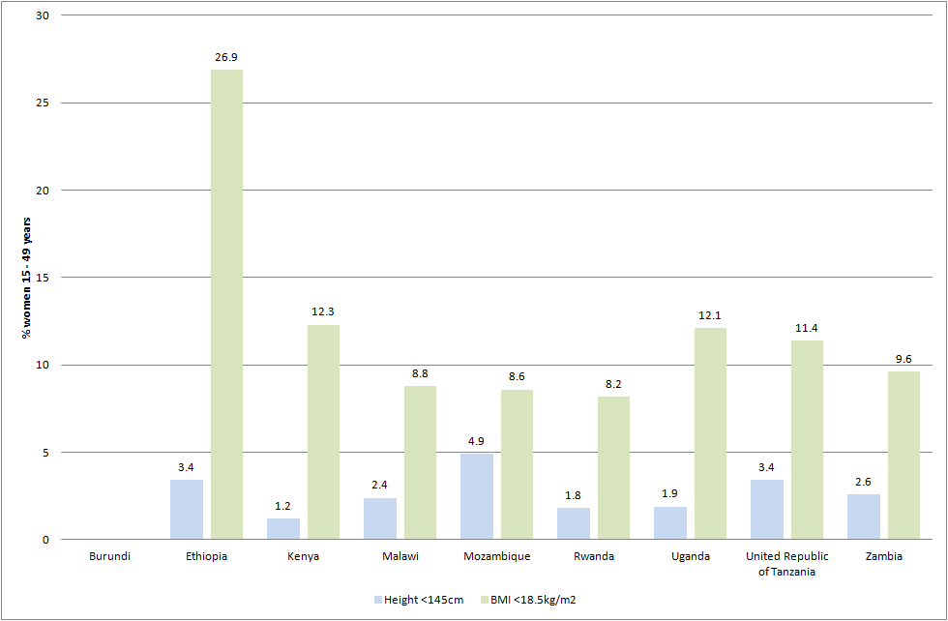
Figure 3 Prevalence of short stature (<145cm) and BMI <18.5 kg/m² in women 15 – 49 years old.

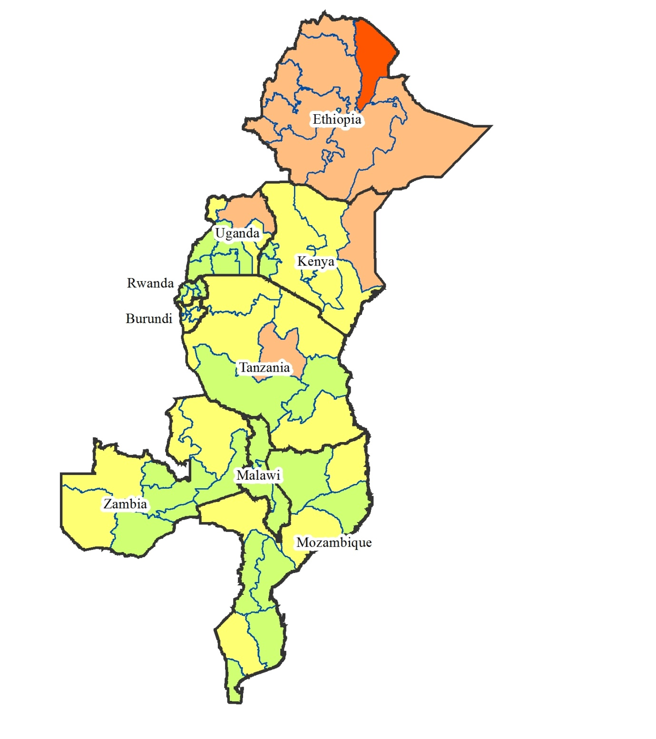

Legend | % adults with BMI <18.5
 | 5-9%: Low prevalence (warning sign, monitoring required)
 | 10 – 19%: Medium prevalence (poor situation)
 | 20 – 39%: High prevalence (serious situation)
 | ≥40%: Very high prevalence (critical situation)

Map 4 Distribution of rates of BMI <18.5 kg/m² amongst focus countries at the district scale

Micronutrient deficiencies
Three of the most prevalent micronutrient deficiencies in populations in developing countries in particular are iron deficiency, iodine deficiency, and Vitamin A deficiency (Black et al. 2008).
Iron deficiency is the most common nutritional disorder in the world. Iron deficiency is caused by low levels of iron in the diet including low consumption of meat, fish or poultry, especially in poor people (Black et al. 2008). In young children the peak prevalence of iron deficiency anaemia occurs around 18 months of age and then falls as iron requirements decline and iron intake is increased through complementary foods (Black et al 2008). Women of child-bearing age are also at a high risk of a negative iron balance because of blood loss during menstruation and the substantial iron demands of pregnancy. Loss or destruction of red blood cells by hookworm and malaria is often accompanied by inadequate consumption of iron-rich foods (Basch 1999). The effects of iron deficiency include iron deficiency anaemia, reduced work capacity, diminished learning ability, an increased susceptibility to infection and a greater risk of death associated with pregnancy and childbirth (Basch 1999). Anaemia can be a particularly serious problem for pregnant women, leading to premature delivery and low birthweight. Anaemia in children is also associated with impaired mental and physical development. Iron deficiency is measured by haemoglobin concentration, with concentrations less than 110 – 112 g/L or 11 – 12 dl/L classifying people as ‘anaemic’.

Iodine deficiency is the greatest single cause of preventable brain damage and mental retardation in the world (Basch 1999). Insufficient intake of iodine causes a variety of physical and mental disabilities known collectively as iodine deficiency disorders (IDDs). The best known of these are goitre, an enlargement of the thyroid gland, and cretinism, a severe form of mental retardation that may be associated with deaf-mutism, dwarfism and spastic palsy of the lower limbs. Iodine deficiency is the major preventable form of intellectual handicap and can lead to spontaneous abortion and neonatal deaths (Basch 1999). IDD is not only a public health issue, but also an impediment to human and economic development. Iodine deficiency is measured through indicators including urinary iodine concentration (UI), total goitre prevalence (TGP), and through the rates of coverage of adequately iodised salt (>15 ppm) in households. An excess of iodine in the diet can lead to iodine induced hyperthyroidism (IIH).
Vitamin A deficiency is a third micronutrient deficiency that results in a considerable health burden throughout the developing world. Vitamin A is essential for a well-functioning immune system and vision, and its deficiency significantly increases the risk of mortality (Bach 1999; Black et al. 2008). Blindness from corneal scarring due to xerophthalmia is another risk of deficiency in Vitamin A (Black et al. 2008). Severe Vitamin A deficiency can also increase the severity of infections such as measles and diarrhoeal diseases and can slow down recovery from illness. Vitamin A is found in breast milk, other milks, liver, eggs, fish, butter, red palm oil, mangoes, papayas, carrots, pumpkins and dark green leafy vegetables. Globally, an estimated 33 percent (190 million) of preschool-aged children, and 15 percent (19 million) of pregnant women do not have enough Vitamin A in their daily diet, and can be classified as Vitamin A deficient (UNICEF 2009). The WHO Global Database on Vitamin A Deficiency (WHO 2009) reports the public health significance of Vitamin A deficiencies based on prevalence of night blindness and serum retinol levels less than 0.7µg/L in preschool-aged children, and pregnant women.
Statistics on these important and common population-level micronutrient deficiencies are presented in the following section.

Iron deficiency
Data on anaemia in women 15 – 49 (Table 7) and children 6 – 59 months (Table 8) were generally available in the DHS reports. Where this was not available (e.g. Kenya, Zambia) data was taken from the WHO Global Database on Anaemia (WHO 2008). Prevalence rates of ‘any anaemia’ (i.e. haemoglobin <12.0 g/dl) were compared to the WHO Classification for public health significance of rates of anaemia, and classified accordingly between ‘not a problem’ and ‘severe’ (see Table 9).
For women aged 15 – 49 as presented in Table 7, anaemia is at least a ‘mild’ public health problem (>5 percent prevalence) reaching both moderate and severe levels in some countries.
Table 8 presents rates of anaemia amongst children 6 – 59 months; rates of anaemia reported at these times were considered severe, reaching well above 40 percent in many countries. Based on these data iron deficiency anaemia amongst children appears to be a highly significant problem in this region. Map 5 and Map 6 below present these rates of iron deficiency for women and children for each district (where available) to illustrate sub-national distributions.
Table 7 Rates of anaemia in women aged 15 – 49 in selected countries
 | Year | Women 15 – 49 with ‘any’ anaemia (<12.0 g/dl haemoglobin)¹ (%) | Source
Burundi | 2010 | 18.5 | DHS 2010
Ethiopia | 2011 | 16.6 | DHS 2011
Kenya | 1999 | 46.4 | WHO Global Database on Anaemia
Malawi | 2010 | 28.0 | DHS 2011
Mozambique | 2011 | 53.9 | DHS 2011
Rwanda | 2010 | 17.3 | DHS 2010
Uganda | 2006 | 49 | DHS 2007
United Republic of Tanzania | 2010 | 40.1 | DHS 2011
Zambia | 2003 | 29.1 | WHO Global Database on Anaemia
- For Kenya and Zambia, data from the WHO Global Database on anaemia are based on a cut-off of <11.0 g/dl haemoglobin

Table 8 Rates of anaemia in children aged 6 – 59 months in selected countries
 | Year | % of children 6 – 59 months with ‘any’ anaemia (<12.0 g/dl haemoglobin)¹ | Source
Burundi | 2010 | 44.6 | DHS 2010
Ethiopia | 2011 | 44.3 | DHS 2011
Kenya | 1999 | 69.0 | WHO Global Database on Anaemia
Malawi | 2010 | 62.5 | DHS 2011
Mozambique | 2011 | 68.7 | DHS 2011
Rwanda | 2010 | 38.2 | DHS 2010
Uganda | 2006 | 72.6 | DHS 2007
United Republic of Tanzania | 2010 | 58.6 | DHS 2011
Zambia | 2003 | 52.9 | WHO Global Database on Anaemia
- For Kenya and Zambia, data from the WHO Global Database on anaemia are based on a cut-off of <11.0 g/dl haemoglobin

Table 9 Public health significance of population prevalence rates of anaemia¹
Prevalence of any anaemia (%) | Category of public health significance (WHO)
≤4.9 | No public health problem
5.0 – 19.9 | Mild
20.0 – 39.9 | Moderate
≥40 | Severe
1. <11 g/dl haemoglobin

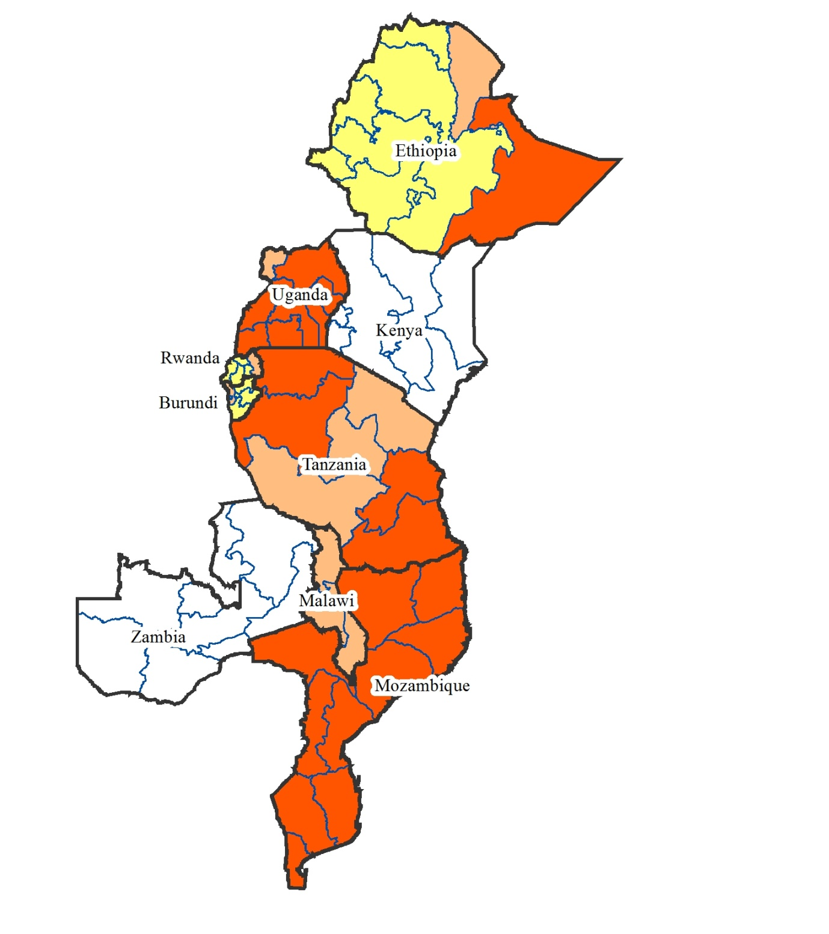

Category of public health significance (WHO) | Prevalence of any anaemia (%)
No public health problem | ≤4.9
Mild | 5.0 – 19.9
Moderate | 20.0 – 39.9
Severe | ≥40
No data

Map 5 District level distribution of rates of anaemia in women 15 – 49 (where available)
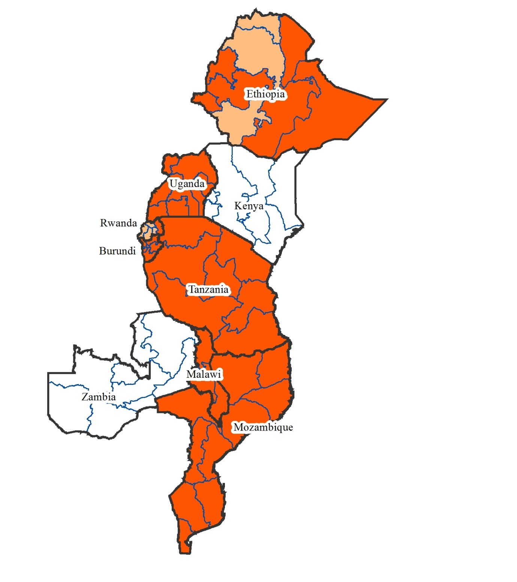

Category of public health significance (WHO) | Prevalence of any anaemia (%)
No public health problem | ≤4.9
Mild | 5.0 – 19.9
Moderate | 20.0 – 39.9
Severe | ≥40
No data

Map 6 District level distribution of rates of anaemia in children 6 – 59 months (where available)

Vitamin A deficiency
For Vitamin A the serum retinol levels as reported by the Global Database on Vitamin A Deficiency (WHO 2009) are presented along with the WHO classification of the seriousness of the reported prevalence statistics. It must be noted however that this data is generally from collections as far back as 1997. More recent data on Vitamin A nutrition is available amongst the DHS reports of the respective countries. This has however not been presented here due to the use of the variety of indicators for Vitamin A nutrition. These include coverage of Vitamin A supplement distribution, and rates of Vitamin A-rich food intake.
The figures in the WHO database have been chosen for purposes of presenting a comparison amongst countries using one consistent indicator, and because of the consistent classification of the serum retinol concentration indicator into levels of ‘public health problem’ (Table 10 and Table 11).
According to the WHO database Vitamin A deficiency emerged as a ‘severe’ public health problem amongst preschool children in almost all of the selected countries (Table 10). Amongst pregnant women, population prevalence of Vitamin A deficiency was generally classified as a ‘moderate’ public health problem in most countries (Table 11). The extent to which these rates of Vitamin A deficiency are considered a public health problem in each focus country are also presented in Map 7 and Map 8 below. Again, we welcome discussion in the workshop on how these situations may have changed since these data were collected.
Table 10 Prevalence of low serum retinol in preschool-aged children
 | Year | Population with serum retinol <0.7µmol/L (%) | Public health problem
Burundi | 2005 | 27.9 | Severe
Ethiopia | 1996/97 | 46.1 | Severe
Kenya | 1999 | 84.4 | Severe
Malawi | 2001 | 59.2 | Severe
Mozambique | 2002 | 68.8 | Severe
Rwanda | 1996 | 6.4 | Mild
Uganda | 2001 | 27.9 | Severe
United Republic of Tanzania | 1997 | 24.2 | Severe
Zambia | 2003 | 54.1 | Severe
Source : WHO 2009
Table 11 Prevalence of low serum retinol in pregnant women
 | Year | Population with serum retinol <0.7 µmol/L (%) | Public health problem
Burundi | - | 12.2 | Moderate
Ethiopia | 1997 | 13.2 | Moderate
Kenya | 1998 | 17.3 | Moderate
Malawi | 1999 | 13.7 | Moderate
Mozambique | 2002 | 14.3 | Moderate
Rwanda | 1996 | 6.2 | Mild
Uganda | 2001 | 23.3 | Severe
United Republic of Tanzania | 2001 | 14.8 | Moderate
Zambia | 2001 | 14.0 | Moderate
Source : WHO 2009

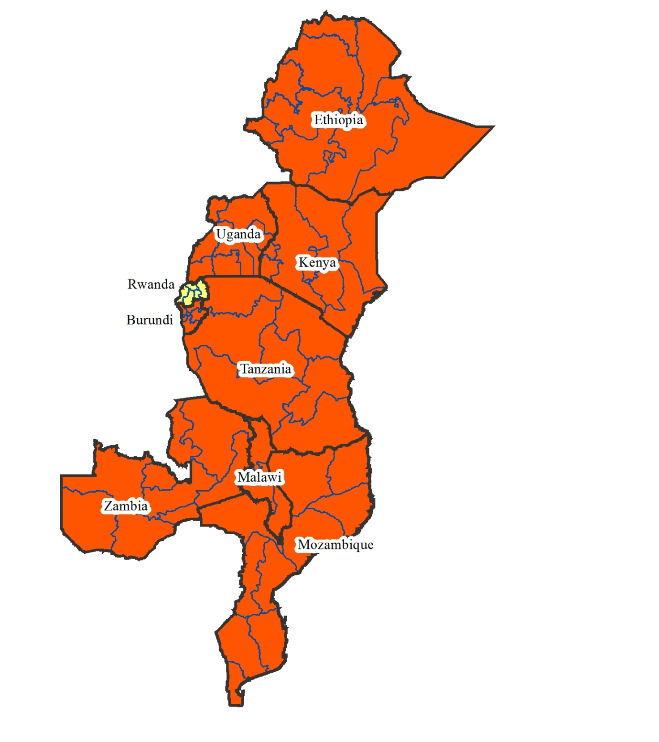

Legend
Public Health Severity
Mild
Moderate
Severe

Map 7 Vitamin A deficiency amongst primary school-aged children
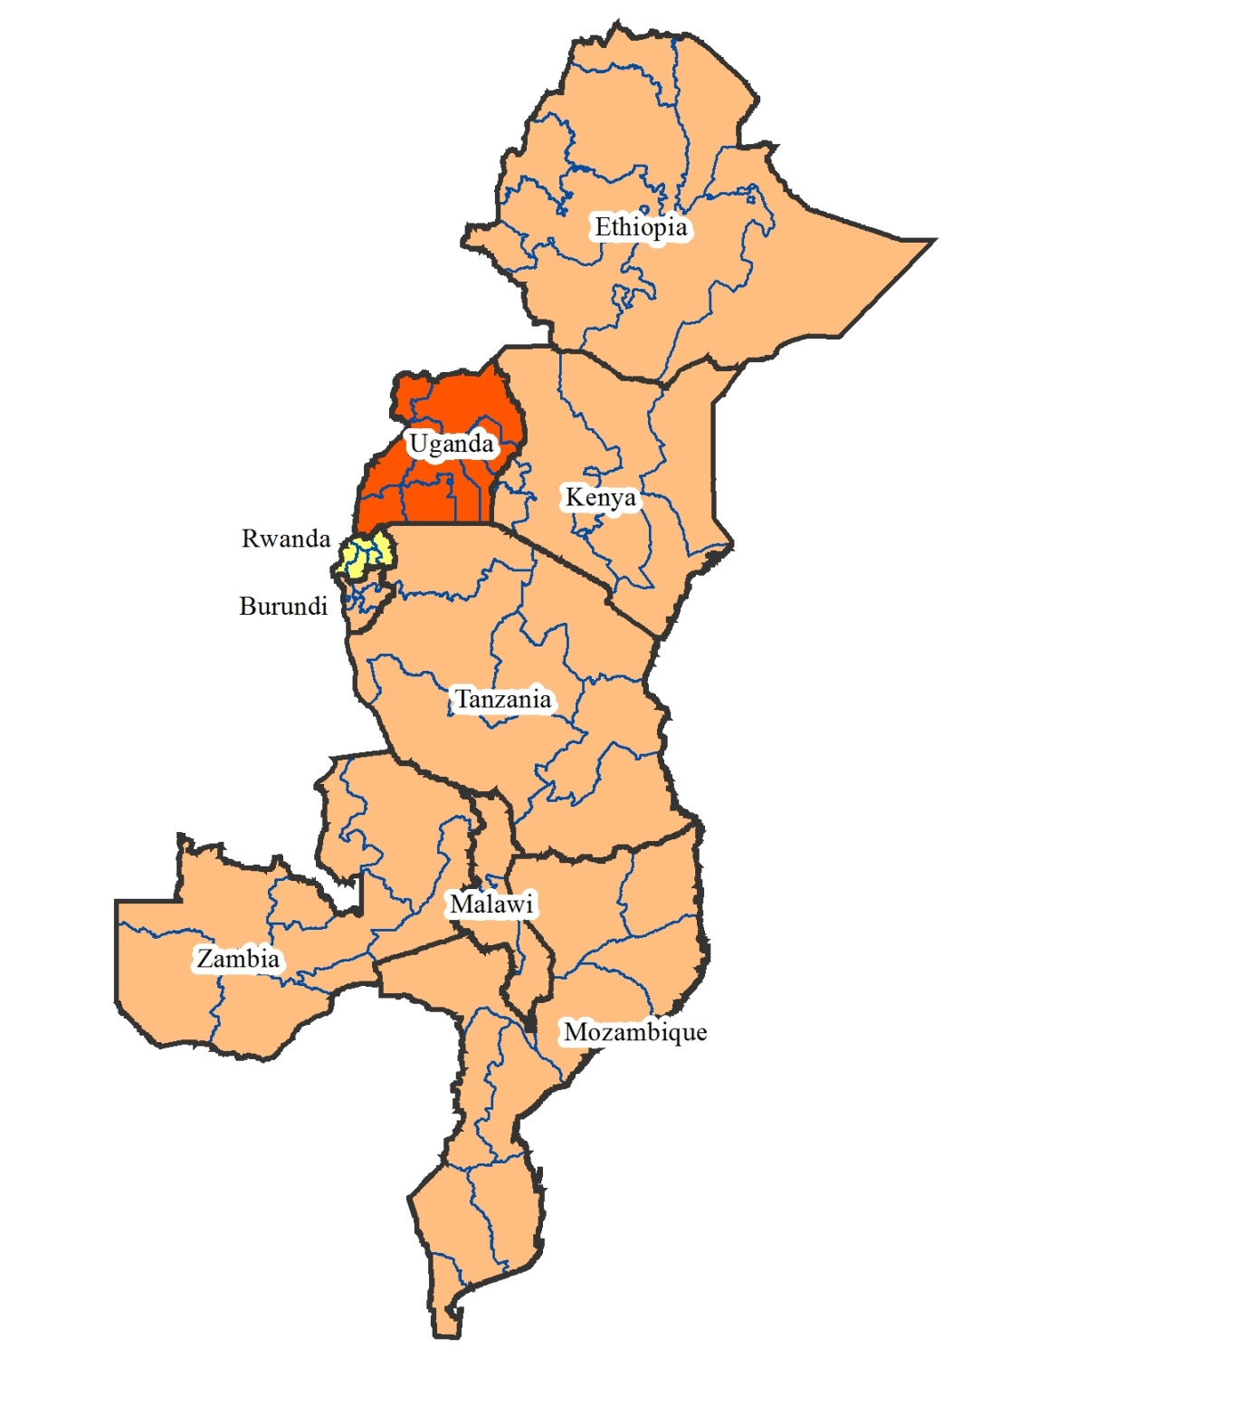

Legend
Public Health Severity
Mild
Moderate
Severe

Map 8 Vitamin A deficiency amongst pregnant women

Iodine deficiency
Iodine nutrition was generally measured by DHS reports in terms of the prevalence of adequately iodised salt. Measures of actual iodine nutrition as measured by urinary iodine (UI) concentrations (µg/L) are reported in the WHO Global Database on Iodine Deficiency (WHO 2004). As with the Global Database on Vitamin A, much of the data was collected up to 18 years ago. These data for iodine nutrition in the AIFSC priority area are presented in Table 12 below, along with the subsequent WHO classification of the iodine intake and iodine nutrition of the populations. Most countries selected had optimal, even excessive levels of iodine nutrition, with adequate to excessive levels of iodine intake. Based on these data, we believe that iodine deficiency may not be a significant nutrition issue in this region.
Table 12 Iodine nutrition in selected countries
 | Date | Median UI (µg/L) | % population with UI <100 µg/L | Classification of iodine intake | Classification of iodine nutrition
Burundi |  | No data in 2004 WHO database
Ethiopia | 2000 | 58 | 68.4 | Insufficient | Mild iodine deficiency
Kenya | 1994 | 115 | 36.7 | Adequate | Optimal iodine nutrition
Malawi | No data in 2004 WHO database
Mozambique | 1998 | 69 | 65.4 | Insufficient | Mild iodine deficiency
Rwanda | 1996 | 298 | 0.0 | More than adequate | Risk of IIH in susceptible groups
Uganda | 1999 | 310 | 11.9 | Excessive | Risk of adverse health consequences
United Republic of Tanzania | 1996 | 127 | 37.7 | Adequate | Optimal iodine nutrition
Zambia | 1993 | 60 | 72.0 | Insufficient | Mild iodine deficiency
Source : WHO 2004

Conclusion
This paper has aimed to present a snapshot of the nutrition profiles for a series of selected indicators of child, maternal and population nutrition for the AIFSC focus countries of east and southern Africa. Data provided should be a starting point for further discussion of trends, drivers and issues affecting population nutrition in this region. Stunting amongst children under five years old and Vitamin A deficiency amongst preschool-aged children stand out as key issues for the most of the countries.
During this workshop, we hope to use your expert knowledge to identify the key food security, public health or other potential drivers of the nutritional status of people in this region.
Through creating an accurate picture of nutrition and food security issues in this region, we will be able to identify key strategic areas for future investments and partnerships.

References
Basch, P.F. (1999). Textbook of International Health. Second Edition. Oxford University Press, New York.
Bhutta, Z.A., Ahmed T., Black, R.E, Cousens, S., Dewey, K., Giugliani, E., Haider, B.A., Kirkwood, B., Morris, S.S., Sachdev, H.P.S., Shekar, M. (2008). Maternal and child undernutrition 3: What works? Interventions for maternal and child undernutrition and survival. Lancet 371: 417 – 439.
Black, R.E., Allen, L.H., Bhutta, Z.A., Caulfield, L.E., de Onis, M., Ezzati, M., Mathers, C., Rivera, J. (2008). Maternal and child undernutrition 1: Maternal and child undernutrition: global and regional exposures and health consequences. Lancet 371: 243 – 260.
Central Statistics Office (2009). Botswana Family Health Survey 2007. Gaborone, Botswana.

National Bureau of Statistics (NBS) [Tanzania] and ICF Macro (2011). Tanzania Demographic and Health Survey 2010. Dar es Salaam, Tanzania: NBS and ICF Macro.

SUN Movement (2011). Scaling Up Nutrition – A Framework for Action. Available at: http://siteresources.worldbank.org/NUTRITION/Resources/281846-1131636806329/PolicyBriefNutritionScalingUpApril.pdf (accessed 10/7/12).
UNICEF (2009). Tracking Progress on Child and Maternal Nutrition. Available at: http://www.unicef.org/publications/files/Tracking_Progress_on_Child_and_Maternal_Nutrition_EN_110309.pdf (accessed 10/7/12).
World Food Programme (WFP) (2012). WFP Nutrition Policy. Available at: http://documents.wfp.org/stellent/groups/public/documents/eb/wfpdoc061668.pdf (accessed 25/7/12).
World Health Organisation (WHO) 2004. Iodine status worldwide – WHO Global Database in Iodine Deficiency. Geneva.
WHO (2006). WHO Multicentre Growth Reference Study Group. WHO Child Growth Standards: length/height-for-age, weight-for-age, weight-for-length, weight-for-height and body mass index-for-age. Geneva.
WHO (2008). Worldwide prevalence of anaemia 1993 – 2005: Global Database on Anaemia. Available at: http://who.int/vmnis/database/anaemia/countries/en/index.html (accessed 24/7/12).
WHO (2009). Global prevalence of Vitamin A deficiency in populations at risk 1995 – 2005. WHO Global Database on Vitamin A Deficiency. Geneva. Available at: http://www.who.int/vmnis/database/vitamina/countries/en/index.html (accessed 25/7/12).
WHO (2012). Global Database on Body Mass Index: Available at: http://apps.who.int/bmi/index.jsp (accessed 25/7/12).
WHO (2012a) – Global Database on Child Growth and Malnutrition. Available at: http://www.who.int/nutgrowthdb/about/introduction/en/index5.html (accessed 20/08/12).

Annex 1 – List of references for Demographic Health Survey reports
Country | Year | Reference for Demographic and Health Surveys (DHS)
Burundi | 2010 | Institut de Statistiques et d’Etudes Economiques (ISEE) du Burundi (2010) Enquete Demographique et de Sante Burundi 2010 – Rapport Preliminaire.
Ethiopia | 2011 | Central Statistics Agency, Ethiopia (2011) Ethiopia Demographic Health Survey 2011.
Kenya | 2008-09 | Kenya National Bureau of Statistics (KNBS) and ICF Macro. (2010). Kenya Demographic and Health Survey 2008-09. Calverton, Maryland: KNBS and ICF Macro.
Malawi | 2010 | National Statistical Office (NSO) and ICF Macro. (2011). Malawi Demographic and Health Survey 2010. Zomba,  Malawi, and Calverton, Maryland, USA: NSO and ICF Macro.
Mozambique | 2011 | Instituto Nacional de Estatística; Ministério da Saúde Maputo, Moçambique (2011). Moçambique  Inquérito Demográfico e de Saúde 2011 – Relatório Preliminar.
Rwanda | 2010 | National Institute of Statistics of Rwanda (NISR) [Rwanda], Ministry of Health (MOH) [Rwanda], and ICF International. (2012). Rwanda Demographic and Health Survey 2010. Calverton, Maryland, USA: NISR, MOH, and ICF International.
Uganda | 2006 | Uganda Bureau of Statistics (UBOS) and Macro International Inc. (2007). Uganda Demographic and Health Survey 2006. Calverton, Maryland, USA: UBOS and Macro International Inc.
United Republic of Tanzania | 2010 | National Bureau of Statistics (NBS) [Tanzania] and ICF Macro. (2011).  Tanzania Demographic and Health Survey 2010. Dar es Salaam, Tanzania: NBS and ICF Macro.
Zambia | 2007 | Central Statistical Office (CSO), Ministry of Health (MOH), Tropical Diseases Research Centre (TDRC), University of Zambia, and Macro International Inc. (2009). Zambia Demographic and Health Survey 2007. Calverton, Maryland, USA: CSO and Macro International Inc.

Annex 2 Country summaries and discussion

Burundi
According to the preliminary report of the 2010 Demographic and Health Survey for Burundi, results showed a national rate of stunting of 57.7 percent, with 27.1 percent severely stunted. Six percent of children are wasted and 1 percent of children are severely wasted. It is among children 6 to 7 months the level of wasting is highest. This age group corresponds to the period during which there was an increase in weaning and infant exposure to diseases caused by the introduction of new foods that can be prepared in non-hygienic environments. At this age, children also being to explore the immediate environment that can also increase their exposure to infection. The national rate of underweight amongst children 6 – 59 months in Burundi is approximately 30 percent with nearly 8 percent classified as severely underweight (Institut de Statistiques et d’Etudes Economiques (ISEE) du Burundi 2010).
The latest data available for rates of low birthweight in Burundi are reported in the UNICEF Multiple Indicator Cluster Survey (MICS) from 2000, and was reported at 16 percent.
Data on maternal short stature and BMI were not reported in the Burundi DHS for 2010.
In 2010 the national rate of anaemia in Burundi amongst children 6 – 59 months is 44.6 percent, with 1 percent having severe anaemia (<7.0 g/dl haemoglobin).This rate of anaemia among children is considered to be severe by WHO standards. The national rate of anaemia amongst women 15 – 49 was 18.5 percent: a rate considered mild by WHO standards (WHO 2008).
In 2005, Vitamin A deficiency as measured by serum retinol levels affects 28 percent of children and 12 percent of women, with these levels of deficiency classified as ‘severe’ for children, and ‘moderate’ for women (WHO 2009). Night blindness affected 8 percent of pregnant women in Burundi and is considered by WHO as a public health problem.
There was no data on iodine deficiency in Burundi in the WHO Global Database or the most recent Burundi DHS.

Table A Summary of undernutrition statistics for Burundi
Indicator | Year | Value | Public health significance
Stunting (% <-2 Z-scores) | 2010 | 57.7 | Very high
Wasting (% <-2 Z-scores) | 2010 | 5.8 | Medium
Underweight (% <-2 Z-scores) | 2010 | 28.8 | High
BMI in women 15 – 49 (%<18.5) | No data
Women <145cm in height (%) | No data
Pregnant women with serum retinol <0.7 µmol/L (%) | - | 12.2 | Moderate
Preschool-aged children with serum retinol <0.7 µmol/L (%) | 2005 | 27.9 | Severe
Women 15 – 49 with anaemia (haemoglobin <12.0 g/L) (%) | 2010 | 18.5 | Mild
Children 6 – 59 months with anaemia (haemoglobin <12.0 g/L) (%) | 2010 | 44.6 | Severe
Iodine deficiency (% population with UI <100 µg/L) | No data in 2004 WHO database

Ethiopia
In 2011 the national rate of stunting amongst children under five was 44 percent and 21 percent were severely stunted, with children in rural areas one and a half times more likely to be stunted (46 percent) than those in urban areas (32 percent). Stunting was more common among children who were small at birth (52 percent). Similarly, children whose mothers are thin were more likely to be stunted (47 percent) than children with overweight or obese mothers.
Overall, 10 percent of children in Ethiopia were wasted and 3 percent were severely wasted. Ten percent of children in rural areas were wasted relative to 6 percent in urban areas. The analyses in the DHS reported inverse relationships were observed between stunting and wasting levels with mothers’ education level and household wealth quintile. Children with mothers with secondary education were least likely to be stunted (19 percent) while children with mothers with no education were the most likely to be stunted (47 percent). Wasting was also most common amongst children whose mothers had no education, were thin (BMI <18.5) and who were in the lowest wealth quintile.
In 2011, 29 percent of children under five were underweight and 9 percent were severely underweight. The global prevalence of low birthweight (<2500 g) was 11 percent. Inverse correlations were evident between low birthweight and wasting, with a high proportion of babies reported as low birthweight (14 percent) being acutely malnourished compared to 8 percent of children reported as average or larger in size at birth.
In terms of anthropometric indicators of nutrition for women 15 – 49, three percent of Ethiopian women in 2011 were less than 145cm in height. Women of short stature were most likely to reside in the Amhara region and to have no education (Central Statistics Agency, Ethiopia 2011). The mean BMI for Ethiopian women is 20 kg/m². No major differences are evident amongst the mean BMI of women from rural or urban areas, region, or education status. Sixty-seven percent of Ethiopian women had a normal BMI (18.5 – 24.9) while 27 percent have a BMI <18.5 kg/m², a prevalence considered ‘serious’ and ‘high’ by WHO standards for public health significance (Central Statistics Agency, Ethiopia 2011).
Amongst women 15 – 49, 13.1 percent had mild anaemia, 2.9 percent had moderate anaemia and 0.6 percent had severe anaemia with a total rate of any anaemia of just over 16 percent. This level is considered mild by WHO standards. Levels of anaemia levels among children age 6 – 59 months were almost 45 percent, a rate considered to be severe by WHO standards. One child in five (21 percent) had mild anaemia, another 20 percent had moderate anaemia, and approximately 3 percent had severe anaemia. Anaemia prevalence was highest among children age 9-11 months (73 percent) and decreased steadily with age from 12 to 59 months (DHS 2011). Forty-five percent of children in rural areas had anaemia, compared with 35 percent of children in urban areas. The prevalence of moderate anaemia decreased from 28 percent in 2005 to 20 percent in 2011 (Central Statistics Agency, Ethiopia 2011).
Vitamin A deficiency is considered a public health problem in Ethiopia, with the 2011 DHS reporting that 46 percent of preschool-aged children have serum retinol levels <7.0µmol/L. The level of night blindness among pregnant women was 22 percent, and was considered a public health problem by WHO (WHO 2009).
The iodine nutrition of Ethiopia is classified as a ‘mild deficiency’, with the population intake considered ‘insufficient’. The Global Database on Iodine Deficiency (WHO 2004) reports 68.4 percent of the population with a UI concentration of <100µg/L.
Table B Summary of undernutrition statistics for Ethiopia
Indicator | Year | Value | Public health significance
Stunting (% <-2 Z-scores) | 2011 | 44.4 | Very high
Wasting (% <-2 Z-scores) | 2011 | 9.7 | High
Underweight (% <-2 Z-scores) | 2011 | 28.7 | High
BMI in women 15 – 49 (%<18.5) | 2011 | 26.9 | High prevalence (serious situation)
Women <145 cm in height (%) | 2011 | 3.4 | NA
Pregnant women with serum retinol <0.7 µmol/L (%) | 1997 | 13.2 | Moderate
Preschool-aged children with serum retinol <0.7 µmol/L (%) | 1996/97 | 46.1 | Severe
Women 15 – 49 with anaemia (haemoglobin <12.0 g/L) (%) | 2011 | 16.6 | Mild
Children 6 – 59 months with anaemia (haemoglobin <12.0 g/L) (%) | 2011 | 44.3 | Severe
Iodine deficiency (% population with UI <100 µg/L) | 2000 | 68.4 | Mild iodine deficiency

Kenya
The Kenyan DHS 2008 – 2009 reported that 1 percent of women of women in Kenya are less than 145cm tall. The mean BMI for women 15 – 49 was 23 kg/m². At the national level 12 percent of women were considered to be thin (BMI <18.5), with the highest rates of ‘thinness’ in the North Eastern province (26 percent) and the lowest rate in Nairobi (3 percent).
Birthweight amongst children in Kenya was reported for just under half of births. Of those with a recorded birthweight 94 percent weighed 2.5 kg or more, and only 6 percent were of low birthweight (<2.5 kg). Socioeconomic differentials in child’s birth weight are not large; however children whose mothers have no education are more likely to be smaller than average or very small compared with children whose mothers have at least some education (Kenya National Bureau of Statistics (KNBS) and ICF Macro 2010).
Similarly, there is a decrease in the proportion of babies considered to be smaller than average or very small as the wealth quintile of the mother increased (Kenya National Bureau of Statistics (KNBS) and ICF Macro 2010)
The national rate of stunting in Kenya was reported at 35 percent and the percentage severely stunted as 14 percent. This rate is considered to be ‘high’ by the WHO classification for seriousness of population prevalence of stunting. The BMI of mothers showed an inverse relationship with stunting in children, with mothers with a BMI <18.5 kg/m² having the highest rate of children who are stunted (45 percent), while mothers who were overweight / obese (BMI ≥25 kg/m²) having the lowest rate of stunted children (27 percent). The mother’s level of education also showed an inverse relationship with rates of stunting in their children.
Overall in Kenya 7 percent of children were reported as wasted and 2 percent were severely wasted. This prevalence is considered of ‘medium’ public health significance by WHO standards. In this 2008-09 DHS, the North Eastern province had extraordinarily high levels of wasting with 20 percent of children under five in North Eastern Province were wasted, and 8 percent were severely wasted. These levels may reflect food stress in the region, which is traditionally a region with food deficits. As with stunting, negative correlations were observed between rates of wasting, and maternal education, wealth and nutritional status.
Sixteen percent of children under five in Kenya were underweight, and 4 percent were severely underweight. Rural children were more likely to be underweight (17 percent) than urban children (10 percent), with highest rates of moderate and severely underweight children (25 percent) in the North Eastern province, while Nairobi province had the lowest proportion (8 percent).
The latest reported figures for anaemia in Kenya are from 1999, with the WHO Global Database on Anaemia (WHO 2008) reporting a total rate of any anaemia among non-pregnant women aged 15 – 49 of a little over 46 percent. This prevalence is considered severe by WHO standards. Amongst children 6 – 59 months, the prevalence of anaemia was even higher, at 69 percent. This is also considered of severe public health significance by WHO (WHO 2008).
In 1999, Vitamin A deficiency as measured by serum retinol levels in preschool-aged children was considered severe (WHO 2009) with over 84 percent of children with levels <7.0µmol/g. In 2003, night blindness affected 6.4 percent of pregnant women in Kenya and was considered a public health problem by WHO (WHO 2009).
Iodine deficiency is not a problem in Kenya, with iodine nutrition described as ‘optimal’ by the WHO Global Database on Iodine Deficiency (WHO 2004). The 2011 DHS reported 98 percent of women who gave birth in the five years before the survey had adequately iodised salt in the home. The availability and use of iodised salt in Kenya is considered to be almost universal (Kenya National Bureau of Statistics and ICF Macro 2010).
Table C Summary of undernutrition statistics for Kenya
Indicator | Year | Value | Public health significance
Stunting (% <-2 Z-scores) | 2008-09 | 35 | High
Wasting (% <-2 Z-scores) | 2008-09 | 7 | Medium
Underweight (% <-2 Z-scores) | 2008-09 | 16 | Medium
BMI in women 15 – 49 (%<18.5) | 2008-09 | 12.3 | Medium prevalence (poor situation)
Women <145 cm in height (%) | 2008-09 | 1.2 | NA
Pregnant women with serum retinol <0.7 µmol/L (%) | 1998 | 17.3 | Moderate
Preschool-aged children with serum retinol <0.7 µmol/L (%) | 1999 | 84.4 | Severe
Women 15 – 49 with anaemia (haemoglobin <11.0 g/L) (%) | 1999 | 46.4 | Severe
Children 6 – 59 months with anaemia (haemoglobin <11.0 g/L) (%) | 1999 | 69.0 | Severe
Iodine deficiency (% population with UI <100 µg/L) | 1994 | 36.7 | Optimal iodine nutrition

Malawi
The preliminary report of the 2010 Malawi DHS reported a national rate of stunting amongst children under five in Malawi of 47 percent, with a slightly higher percentage amongst rural children (48 percent) compared to urban children (41 percent). Almost half the children in all three regions of Malawi were stunted with 45 percent in the North, 47 percent in the Central region and 48 percent in the South. Stunting decreased with the level of education of the mother, from a high of 53 percent among children of mothers with no education, to a low of 39 percent among children of mothers with a secondary education.
The national rate of wasting in Malawi was 4 percent, and almost half of these were classified as severely wasted (1.5 percent). Variation in levels of wasting existed between urban and rural populations, these being 2 percent and 4 percent respectively. Children in the Central and South regions were twice as likely to be wasted as children in the North with rates of 4 percent in the Central and South compared to 2 percent in the North.
Thirteen percent of all children under five in Malawi were underweight, were 3 percent are severely underweight. Thirteen percent of rural children were underweight compared to 10 percent of urban children. Similarly to stunting and wasting, the Central and South regions had higher rates of underweight than the North, with rates of 14 percent, 13 percent and 11 percent respectively.
The DHS 2010 reported 2.4 percent of women to have short stature (>145cm). Short stature decreased with increasing level of education and wealth status. Nine percent of women were thin, of which 2 percent were moderately or severely thin. The proportion of women who were thin is higher among women aged 15-19, those in rural areas, those in the Central and Southern Regions, and those with lower levels of education and wealth (National Statistical Office (NSO) and ICF Macro. 2011).
The DHS 2010 for Malawi reported for 67 percent of the live births that occurred in the five years preceding the survey. Of these, 12 percent of these infants had low birth weights (less than 2.5 kg). Younger mothers (age 20 or less) and older mothers (age 35-49) were most likely to have infants with low birth weight when compared with mothers aged 20-34. Among the regions, the Southern Region has the lowest proportion of low birth weight infants, and the Central Region had the highest proportion (11 and 14 percent, respectively). There is an inverse relationship between low birth weight and mother’s education. The same trend is observed among wealth quintiles (National Statistical Office (NSO) and ICF Macro. 2011).
Approximately 63 percent of children 6 – 59 months in Malawi were anaemic, with 24 percent mildly anaemic, 36 percent moderately anaemic and 3 percent severely anaemic. Children in rural areas had higher rates of anaemia than those in urban areas with rates of 64 percent and 53 percent respectively (National Statistical Office (NSO) and ICF Macro. 2011). Twenty-eight percent of women 15 – 49 in Malawi were anaemic. While there is a moderate variation by rural–urban residence, differences vary greatly by district ranging from a high of approximately 50 percent in Mangochi to 20 percent in Chitipa (National Statistical Office (NSO) and ICF Macro. 2011).
Vitamin A deficiency was also considered a severe public health problem among children in Malawi, with almost 60 percent of children with serum retinol levels <7.0µmol/L (WHO 2009). Night blindness affected almost 6 percent of pregnant women, and was also considered to be a public health problem by WHO (WHO 2009).
There is no data for Malawi on iodine deficiency in the WHO Database on Iodine Deficiency. Rates of iodised salt use in households are reported as above 90 percent amongst all regions surveyed during the 2010 DHS (National Statistical Office (NSO) and ICF Macro. 2011).
Table D Summary of undernutrition statistics for Malawi
Indicator | Year | Value | Public health significance
Stunting (% <-2 Z-scores) | 2010 | 47.1 | Very high
Wasting (% <-2 Z-scores) | 2010 | 4.0 | Low
Underweight (% <-2 Z-scores) | 2010 | 12.8 | High
BMI in women 15 – 49 (%<18.5) | 2010 | 8.8 | Low prevalence (warning sign, monitoring required)
Women <145 cm in height (%) | 2010 | 2.4 | NA
Pregnant women with serum retinol <0.7 µmol/L (%) | 1999 | 13.7 | Moderate
Preschool-aged children with serum retinol <0.7 µmol/L (%) | 2001 | 59.2 | Severe
Women 15 – 49 with anaemia (haemoglobin <12.0 g/L) (%) | 2010 | 28.0 | Moderate
Children 6 – 59 months with anaemia (haemoglobin <12.0 g/L) (%) | 2010 | 62.5 | Severe
Iodine deficiency (% population with UI <100 µg/L) | No data in 2004 WHO database

Mozambique
The preliminary report of the Mozambique 2011 DHS reported a very high rate of stunting among children under five of almost 43 percent with a rate of severe stunting of almost 20 percent. Rates of wasting and underweight amongst children under five were of ‘medium’ public health severity at 6 percent and 15 percent respectively (Instituto Nacional de Estatística Ministério da Saúde Maputo, Moçambique 2011).
Data on maternal nutrition and low birthweight babies were not available in the 2011 preliminary report, so the latest figures were from the 2003 DHS. In 2003, approximately 5 percent of women 15 – 49 years of age were <145cm in height, and almost 9 percent of women had a BMI <18.5 kg/m², a prevalence considered ‘low’ by WHO standards. Six percent of term births in Mozambique were reported as <2500g in the 2003 DHS.
Data on anaemia rates amongst women and children were available in the 2011 preliminary report. Among women 15 – 49, almost 54 percent were classified as anaemic. Almost 39 percent had mild anaemia, 14 percent had moderate anaemia and almost 2 percent had mild anaemia. Almost 70 percent of children 6 – 59 months in Mozambique were anaemic, with 4 percent severely anaemic, almost 40 percent moderately anaemic and 26 percent with mildly anaemic (Instituto Nacional de Estatística Ministério da Saúde Maputo, Moçambique 2011).
Vitamin A deficiency was also reported as a severe public health problem amongst children in Mozambique. The Global Database on Vitamin A Deficiency reported almost 70 percent of preschool-aged children in Mozambique to be Vitamin A deficient (WHO 2009). Night blindness among pregnant women was also considered a public health problem, affecting 5.3 percent of women in 2004 (WHO 2009).
Iodine nutrition in Mozambique was considered to be ‘mildly deficient’. The WHO Global Database on Iodine Nutrition reports approximately 65 percent of the population as having UI levels <100µg/L although the data is from 1998. No updated data were reported in the latest DHS (Instituto Nacional de Estatística Ministério da Saúde Maputo, Moçambique 2011).

Table E Summary of undernutrition statistics for Mozambique
Indicator | Year | Value | Public health significance
Stunting (% <-2 Z-scores) | 2011 | 42.6 | Very high
Wasting (% <-2 Z-scores) | 2011 | 5.9 | Medium
Underweight (% <-2 Z-scores) | 2011 | 14.9 | Medium
BMI in women 15 – 49 (%<18.5) | 2003 | 8.6 | Low prevalence (warning sign, monitoring required)
Women <145 cm in height (%) | 2003 | 4.9 | NA
Pregnant women with serum retinol <0.7 µmol/L (%) | 2002 | 14.3 | Moderate
Preschool-aged children with serum retinol <0.7 µmol/L (%) | 2002 | 68.8 | Severe
Women 15 – 49 with anaemia (haemoglobin <12.0 g/L) (%) | 2011 | 53.9 | Severe
Children 6 – 59 months with anaemia (haemoglobin <12.0 g/L) (%) | 2011 | 68.7 | Severe
Iodine deficiency (% population with UI <100 µg/L) | 1998 | 65.4 | Mild iodine deficiency

Rwanda
In 2010 the rate of wasting in Rwandan children was 3 percent and about 1 percent was severely wasted. Approximately 11 percent of children under five were underweight and 2 percent were severely underweight. The prevalence of stunting in Rwanda was considered ‘very high’ by WHO population reference standards, reaching almost 45 percent nationally (National Institute of Statistics of Rwanda 2010).
In 2010, almost 2 percent of women were <145 cm in height, with a ‘low prevalence’ of thinness among women 15 – 49, with 8 percent classified as ‘thin’ with a BMI less than 18.5 kg/m² (National Institute of Statistics of Rwanda 2012).
Among births with known birthweight, only 6 percent were classified as having low birth weight (i.e. weighing less than 2.5 kg at birth). According to the respondent’s own assessment of her infant’s size, the majority of infants (84 percent) were classified as average or larger than average. More than one in ten births was either smaller than average (13 percent) or very small (2 percent). Although the differences are not large, children born in rural areas were more likely than those born in urban areas to weigh less than 2.5 kg or to be described as very small in size. Data also show that, in general, there was a positive relationship between the mother’s education and wealth quintile and the weight and size of the newborn (National Institute of Statistics of Rwanda 2012).
Anaemia was reported as common among children in Rwanda; nearly two in five (38 percent) children were anaemic. Practically all children who suffered from anaemia were mildly anaemic (24 percent of all children) or moderately anaemic (14 percent of all children). Less than one percent of children were severely anaemic. Anaemia was less common among women; 17 percent showed any evidence of anaemia, and the majority of these women were mildly anaemic (14 percent of all women). The prevalence of anaemia varied by residence and by region among both children and women (National Institute of Statistics of Rwanda 2010).
Of the selected countries, Rwanda had the lowest prevalence of Vitamin A deficiency among children, and Vitamin A deficiency was considered a ‘mild’ public health problem among children. However, levels of night blindness in 2005 among pregnant women were considered a public health problem, with a prevalence that was higher, or similar to the other selected countries, at almost 8 percent (WHO 2008).
Iodine nutrition in Rwanda was classified as ‘more than adequate’ (WHO 2004). The 2010 DHS reported rates 90 percent and above for coverage of iodised salt in surveyed households (National Institute of Statistics of Rwanda 2012).

Table F Summary of undernutrition statistics for Rwanda
Indicator | Year | Value | Public health significance
Stunting (% <-2 Z-scores) | 2010 | 44.2 | Very high
Wasting (% <-2 Z-scores) | 2010 | 2.8 | Low
Underweight (% <-2 Z-scores) | 2010 | 11.4 | Medium
BMI in women 15 – 49 (%<18.5) | 2010 | 8.2 | Low prevalence (warning sign, monitoring required)
Women <145 cm in height (%) | 2010 | 1.8 | NA
Pregnant women with serum retinol <0.7 µmol/L (%) | 1996 | 6.2 | Mild
Preschool-aged children with serum retinol <0.7 µmol/L (%) | 1996 | 6.4 | Mild
Women 15 – 49 with anaemia (haemoglobin <12.0 g/L) (%) | 2010 | 17.3 | Mild
Children 6 – 59 months with anaemia (haemoglobin <12.0 g/L) (%) | 2010 | 38.2 | Moderate
Iodine deficiency (% population with UI <100 µg/L) | 1996 | 0.0 | Risk of IIH in susceptible groups

Uganda
The 2006 DHS for Uganda reported a national rate of low birthweight at term of 11 percent. Birthweight was lower among children born to older women (35 – 49), first-born children, children born to smoking mothers, and children of women with no education. The birthweight of children also varied between rural and urban areas with prevalence of low birthweight of 12 and 9 percent respectively. Rates of low birthweight varied from a low of 8 percent in the West Nile region to 15 percent in the Central 1 region.
Thirty-eight percent of children under five in Uganda were stunted and 15 percent were severely stunted (Uganda Bureau of Statistics and ICF Macro Inc. 2007). Children with a low birthweight were more likely to be stunted, as were children in rural areas. Rates of stunting between rural and urban populations were 40 percent and 26 percent respectively. Regional variation in nutritional status of children in Uganda was substantial, with the highest rates of stunting in the South West region (50 percent) and the lowest in Kampala (22 percent). The greatest chronic malnutrition problems in Uganda were reported in Karamoja, where over half the children were stunted. Stunting rates were found to be inversely proportional to mother’s level of education, and wealth quintile.
Six percent of children under five were wasted and 16 percent were underweight. In contrast to stunting, rates of wasting varied most substantially among age groups rather than regions, peaking among children aged 9 – 11 months. There was little difference in rates of wasting between rural and urban children. The percentage of children underweight tripled from 11 percent among children under the age of 6 months, to 30 percent among children aged 9 – 11 months. Weaning foods are typically introduced during these ages, and with them an increased exposure to infection as well as inappropriate / inadequate feeding practices, all of which may be contributing to the faltering nutritional status among children in these age groups. Underweight children were more prevalent in rural than urban areas with rates of 17 percent and 11 percent respectively. Rates of underweight ranged from 8 percent in Central 2 region, to 23 percent in the East Central region. In 2006, underweight affected one in five children in IDP camps in the North and more than one in three children in Karamoja (Uganda Bureau of Statistics and ICF Macro Inc. 2007).
Rates of short stature among women were very low, with 2 percent of women being shorter than 145cm. The prevalence of women with a BMI < 18.5 kg/m² was considered of medium prevalence by WHO standards, at just over 12 percent. Women in the age group 15 – 19 were most likely to be undernourished, with rural women reported as being twice as likely to be undernourished as urban women (14 percent and 6 percent respectively).
Anaemia was a critical public health problem in Uganda, where almost three quarters (73 percent) of Ugandan children 6-59 months old were anaemic. Of these, 22 percent were mildly anaemic, 43 percent moderately anaemic and 7 percent severely anaemic. The proportion of anaemia decreased with age, and was higher among male children and children living in rural areas. By region, anaemia prevalence ranged from 52 percent in Kampala to 80 percent in Central 1, Eastern, and North regions. The proportion of children with anaemia was high in both the IDP camps (78 percent) and Karamoja (82 percent). Prevalence of any anaemia decreased with educational attainment and wealth quintile of the mother (Uganda Bureau of Statistics and ICF Macro Inc. 2007).
Vitamin A deficiency among children in Uganda was also classified as a ‘severe’ public health problem, with almost 28 percent of children affected. Levels of deficiency among pregnant women were also considered ‘severe’ in Uganda, with over 23 percent of women with serum retinol levels <7.0µmol/L (in 2001 as reported by the WHO Global Database in Vitamin A deficiency). Levels of night blindness among pregnant women were also high, at 8.3 percent, a level considered to be a public health problem by the WHO.
Iodine nutrition in Uganda was considered ‘excessive’, with a median UI of 310µg/L reported in 1999. WHO considered iodine nutrition in Uganda as ‘at risk of adverse health consequences’ (WHO 2004).
Table G Summary of undernutrition statistics for Uganda
Indicator | Year | Value | Public health significance
Stunting (% <-2 Z-scores) | 2006 | 38.1 | High
Wasting (% <-2 Z-scores) | 2006 | 6.1 | Medium
Underweight (% <-2 Z-scores) | 2006 | 15.9 | Medium
BMI in women 15 – 49 (%<18.5) | 2006 | 12.1 | Medium prevalence (poor situation)
Women <145 cm in height (%) | 2006 | 1.9 | NA
Pregnant women with serum retinol <0.7 µmol/L (%) | 2001 | 23.3 | Severe
Preschool-aged children with serum retinol <0.7 µmol/L (%) | 2001 | 27.9 | Severe
Women 15 – 49 with anaemia (haemoglobin <12.0 g/L) (%) | 2006 | 49 | Severe
Children 6 – 59 months with anaemia (haemoglobin <12.0 g/L) (%) | 2006 | 72.6 | Severe
Iodine deficiency (% population with UI <100 µg/L) | 1999 | 11.9 | Risk of adverse consequences from high median UI in population

United Republic of Tanzania
According to the 2010 DHS, the national rate of stunting amongst children 0 – 59 months was 42 percent, with 17 percent severely stunted (<-3SD). Five percent of children under five were wasted with 1 percent severely wasted. Wasting rates differed throughout the country, with for example; substantially different rates between Tanzania Mainland and Zanzibar at 5 percent and 12 percent respectively).
Sixteen percent of children under five were underweight, with 4 percent severely underweight, and 7 percent of new born children were <2500 g at term birth (National Bureau of Statistics [Tanzania] and ICF Macro. 2011)
In terms of maternal nutrition, 3.4 percent of women aged 15 – 49 in Tanzania were shorter than 145 cm and 11.4 percent had a BMI <18.5. Of these, 9 percent were mildly thin and 2.4 percent were moderately or severely thin (BMI <17).
The Tanzania DHS found that children born to mothers with a BMI >18.5 were three times more likely to be wasted than those born to mothers who were overweight or obese. A strong correlation was also observed between wasting and birthweight, with babies born <2500g much more likely to be underweight. Children born to mothers in the lowest wealth quintile (22 percent) were twice as likely to be underweight than those born to mothers in the highest wealth quintile (11 percent).
The 2010 DHS found that six in ten children (58.6 percent) in Tanzania were anaemic (<12 g/dl haemoglobin). Of these, 27 percent had mild anaemia, 29 percent had moderate anaemia and 2 percent had severe anaemia (National Bureau of Statistics [Tanzania] and ICF Macro. 2011).
Children 9 – 11 months were the most affected by anaemia (81 percent) compared with the other children. Other features of anaemia in Tanzania included a variation in levels between children in Mainland Tanzania who were less likely to be anaemic than children in Zanzibar (58 and 69 percent respectively). In Mainland Tanzania prevalence ranged between 75 percent in Shinyanga and 42 percent in Kilimanjaro and Rukwa. Morogoro had the highest proportion of children with severe anaemia (6 percent). No linear relationship was apparent between anaemia status of children and mother’s education and wealth quintile (National Bureau of Statistics [Tanzania] and ICF Macro. 2011).
The Tanzania DHS 2010 found 40 percent of women 15 – 49 were anaemic, with 1 percent severely anaemic. Pregnant women were more likely to be anaemic (53 percent), possible due to the high demand for iron and folate during pregnancy. Anaemia among women 15 – 49 was more prevalent in urban areas (44 percent) than rural areas (39 percent), and a large disparity was observed between anaemia levels in women from Mainland Tanzania (40 percent) and Zanzibar (59 percent).
Vitamin A deficiency in Tanzania was considered a ‘severe’ public health problem among children, with approximately 24 percent of children affected (WHO 2008).
Iodine nutrition in Tanzania was considered ‘optimal’ by WHO (WHO 2004).

Table H Summary of undernutrition statistics for the United Republic of Tanzania
Indicator | Year | Value | Public health significance
Stunting (% <-2 Z-scores) | 2010 | 42.0 | Very high
Wasting (% <-2 Z-scores) | 2010 | 4.8 | Low
Underweight (% <-2 Z-scores) | 2010 | 15.8 | Medium
BMI in women 15 – 49 (%<18.5) | 2010 | 11.4 | Medium prevalence (poor situation)
Women <145 cm in height (%) | 2010 | 3.4 | NA
Pregnant women with serum retinol <0.7 µmol/L (%) | 2001 | 14.8 | Moderate
Preschool-aged children with serum retinol <0.7 µmol/L (%) | 1997 | 24.2 | Severe
Women 15 – 49 with anaemia (haemoglobin <12.0 g/L) (%) | 2010 | 40.1 | Severe
Children 6 – 59 months with anaemia (haemoglobin <12.0 g/L) (%) | 2010 | 58.6 | Severe
Iodine deficiency (% population with UI <100 µg/L) | 1996 | 37.7 | Optimal iodine nutrition

Zambia
Among the babies for whom birthweight information was obtained for the Zambian DHS 2007, 9 percent had a low birthweight (<2500 g). Mothers younger than the age of 20 were twice as likely to have low birthweight babies (15 percent) than mothers aged 20 – 34 (8 per cent) or mothers 35 – 49 (7 percent).
In terms of anthropometric assessment of nutrition in children 6 – 59 months, 45 percent were stunted, with 2 percent being severely stunted. Five percent of children under five were wasted, and the national prevalence of underweight was 15 percent, with 3 percent being severely underweight (Central Statistics Office, Zambia et al. 2009)
More than 7 in 10 women in Zambia aged 15 – 49 had a normal BMI and 1 in 10 were undernourished or ‘thin’ (BMI <18.5), with women in rural areas more likely to be undernourished than those in urban areas. Nationally, 2.6 percent of women 15 – 40 were below 145cm in height.
Rates of stunting amongst children who were average or large at birth were 44 percent, compared to a rate of 63 percent amongst children who were very small at birth. Other outcomes of the DHS showed that more rural children were stunted (48 percent) than urban children (39 percent). Mothers’ education and wealth were inversely related to stunting with children with mothers with a primary level education only more likely to be stunted (49 percent) than children born to mothers with a secondary education (21 percent) (Central Statistics Office, Zambia et al. 2009).
The latest data available on anaemia among women and children in Zambia is from 2003, as reported in the WHO Global Database on anaemia. The national estimates for anaemia in Zambia in 2003 were approximately 30 percent for women 15 – 49 (non-pregnant women) and a little over 50 percent for children 6 – 59 months (52.9 percent). This rate of anaemia among children was considered a severe public health problem, while rates among women were considered to be of ‘moderate’ public health significance (WHO 2008).
Vitamin A deficiency was also a severe public health problem among children in Zambia, with almost 36 percent affected. Levels of night blindness among children were also considered ‘severe’ among children in Zambia, with the highest level among all the selected countries, of 6.2 percent. Night blindness in pregnant women was also considered a public health problem in Zambia (WHO 2009).
The Global Database in Iodine Deficiency (WHO 2004) reported Zambia as having an ‘insufficient’ iodine intake, with 72 percent of the population with UI levels <100 µg/L. This is the highest rate of deficiency amongst the selected countries. The data was, however, from 1993.

Table I Summary of undernutrition statistics for Zambia
Indicator | Year | Value | Public health significance
Stunting (% <-2 Z-scores) | 2007 | 45.4 | Very high
Wasting (% <-2 Z-scores) | 2007 | 5.2 | Medium
Underweight (% <-2 Z-scores) | 2007 | 14.6 | Medium
BMI in women 15 – 49 (%<18.5) | 2007 | 9.6 | Low – medium
Women <145 cm in height (%) | 2007 | 2.6 | NA
Pregnant women with serum retinol <0.7 µmol/L (%) | 2001 | 14.0 | Moderate
Preschool-aged children with serum retinol <0.7 µmol/L (%) | 2003 | 54.1 | Severe
Women 15 – 49 with anaemia (haemoglobin <11.0 g/L) (%) | 2003 | 29.1 | Moderate
Children 6 – 59 months with anaemia (haemoglobin <11.0 g/L) (%) | 2003 | 52.9 | Severe
Iodine deficiency (% population with UI <100 µg/L) | 1993 | 72.0 | Mild iodine deficiency

The term ‘malnutrition’ includes both undernutrition and overnutrition or obesity. This paper focuses on undernutrition. Country-level nutrition programs may focus on malnutrition, considering both obesity and undernutrition.
It should be noted that results of DHS for many nations based on the NCHS/CDC/WHO Standards are not comparable to results of DHS results based on the new WHO Growth Standards.
While mainly a problem in industrialised countries, overweight is also an emerging nutritional problem facing many developing nations including Guinea-Bissau and Malawi. These countries face the double burden of both stunting and overweight (UNICEF 2009).
Complementary foods refers to those consumed during complementary feeding, which is the process starting when breast milk alone or infant formula alone is no longer sufficient to meet the nutritional requirements of an infant, and therefore other foods and liquids are needed. The target age range for complementary feeding is generally considered to be 6 – 23 months (UNICEF 2009).
Data for Vitamin A were taken from the WHO database rather than the DHS reports for the purpose of consistency in the indicator used (serum retinol levels).

